**The Chronicles of Narnia**

***The Lion, the Witch and the Wardrobe***(*1950*)   
Four ordinary children—Peter, Susan, Edmund, and Lucy Pevensie—discover a wardrobe in Professor Digory Kirke's house that leads to the magical land of Narnia. Narnia has been under the spell of the evil White Witch for 100 years and in a perpetual state of winter. The four children fulfill an ancient, mysterious prophecy—helping the lion Aslan and his army save Narnia from the witch.

***Prince Caspian: The Return to Narnia***(*1951*)   
The Pevensie children return to Narnia, drawn back by Prince Caspian, who blows on Susan's horn to summon help in his hour of need. Caspian, Narnia's rightful ruler, has fled into the woods to escape his uncle, Miraz, who had usurped the throne. The children set out once again to save Narnia. Aided by other Narnians, and ultimately by Aslan, they return the throne to Caspian.

***The Voyage of the Dawn Treader***(*1952*)   
Edmund and Lucy Pevensie, along with their priggish cousin, Eustace Scrubb, return to Narnia. Once there, they join Caspian's voyage to find the seven lords who were banished when Miraz took over the throne. This perilous journey brings them face to face with many wonders and dangers as they sail toward Aslan's country at the end of the world.

***The Silver Chair***(*1953*)   
This is the first Narnia book without the Pevensie children. In their place, Aslan calls their cousin, Eustace Scrubb, back to Narnia together with his classmate Jill Pole. There they are given four signs to find Prince Rilian, Caspian's son, who had been kidnapped ten years earlier. Eustace and Jill, with the help of Puddleglum the Marsh-wiggle, and many others, face great danger before finding Rilian. Rilian, though, has lost his memory due to an enchantment by a silver chair.

***The Horse and His Boy***(*1954*)   
This is the first of the books that does not follow the previous one sequentially. The novel takes place during the reign of the Pevensies in Narnia, an era which begins and ends in the last chapter of *The Lion, the Witch and the Wardrobe*. Bree, a talking horse, and a young boy named Shasta have been held in bondage in Calormen, a country to the south of Narnia. The two meet by chance and plan their return to Narnia and freedom. Discovering on their journey that the Calormenes plan to invade Archenland, they race to alert Archenland's King.

***The Magician's Nephew*** (*1955*)  
Although written five years after *The Lion, the Witch and the Wardrobe*, this book is actually the first in the series—tracing the very beginnings of Narnia—how Aslan created the world and how evil first entered it. Digory Kirke and his friend Polly Plummer stumble into different worlds by experimenting with magic rings made by Digory's uncle (the "magician"). They encounter Jadis (The White Witch), and witness the creation of Narnia. Many long-standing questions about Narnia are answered in this adventure.

***The Last Battle***(*1956*)   
*The Last Battle* chronicles the end of the world of Narnia. Jill and Eustace return to save Narnia from Shift, an ape, who tricks Puzzle, a donkey, into impersonating the lion Aslan. This problem causes a fierce battle between the Calormenes and King Tirian together with Jill, Eustace and a faithful dwarf.

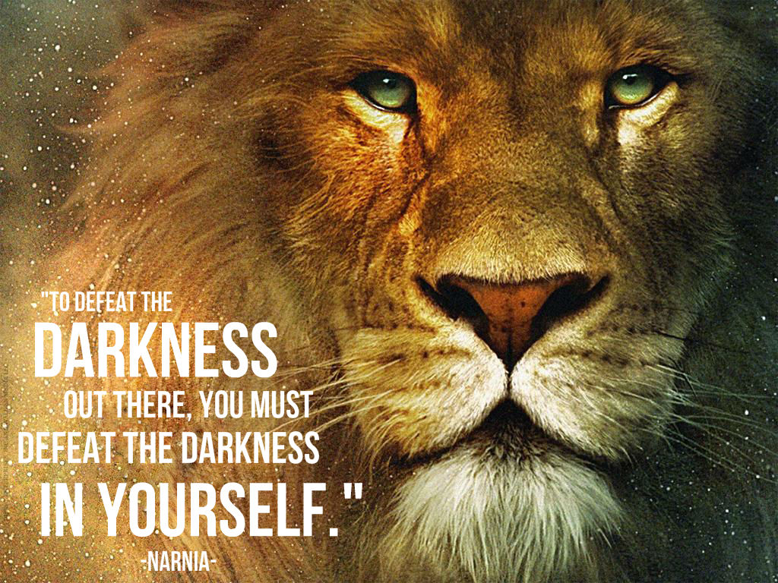Most fiction, like any art, has some reflection of God in it, portraying some aspect of Him through goodness, truth, or beauty. Have you ever read a book which you would consider to be Christian, even if it is not intended as such? Why do you think it is?

“Fairy tales are more than true — not because they tell us dragons exist, but because they tell us dragons can be beaten” –G.K. Chesterton. What do you think of this quote?

The most well-known fictional pieces by C.S. Lewis are *The Chronicles of Narnia* which were intended to be Christian. They are not written as an allegory, although they reflect our own world from creation to the end of time. Do you think that most people who read these books are aware of the Christian influence? Do you think they still convey the message, even if one were unaware of the influence?

Lewis portrays God as coming into the world as a lion- Aslan. Is there any significance to this choice of character? What could a lion symbolize? How would you portray God if you were writing a similar work?

St. Augustine says “the Truth is like a lion; you don’t have to defend it. Set it free; it will defend itself.” What do you make of this quote?

While Narnia is under the rule of the White Witch, it is said that it is always winter but never Christmas. What do you think that means? Lewis elsewhere refers to earth as enemy-occupied territory, meaning that the rightful ruler is cast aside and Satan rules it instead. What does it mean that earth is enemy-occupied territory? How do we witness this happen?

In Narnia, the children are called “Sons of Adam” and “Daughters of Eve.” What does it mean for us to be a “Son or Daughter of Adam and Eve?”

“And now a very curious thing happened. None of the children knew who Aslan was any more than you do; but the moment the Beaver had spoken everyone felt quite different.... At the name of Aslan each one of the children felt something jump in its inside.” Jesus is sometimes referred to as a “live wire” which elicits strong feelings from people – positive or negative. Do you agree with this? Have you experienced this anywhere?

Many of the Chronicles of Narnia involve battle scenes. How do battles figure into our faith? How do we prepare to fight in Christianity?

In one of the climactic moments of *The Lion, the Witch, and the Wardrobe*, Aslan sacrifices himself in order to save one of the children. He submits himself to the punishment under the law of the land, Deep Magic – he is humiliated and put to death on a stone table. But his death is temporary, and is followed by an end of Deep Magic, the cracking of the stone table, and a reversal of death. How does this story sound similar to the crucifixion event of Jesus? How do you understand the crucifixion of Jesus?

Do you think that our world is a battleground for the forces of Good and Evil in the same clear-cut way that Narnia is the site of contention between Aslan and the Witch? Why might it be more difficult to understand what is "right" or "good" in our world than it is in Narnia?

Why are children the main characters in The Lion, the Witch, and the Wardrobe? Why do you think adults can't travel to Narnia, fight for Aslan, and be crowned Kings and Queens at Cair Paravel?

Professor Kirke in *The Lion, the Witch, and the Wardrobe* emphasizes logic in his dealings with the children, even though he is pointing to a supernatural reality that would presumably defy logic. Is it “logical” to believe in the supernatural?

During their journey to Aslan, the children meet Father Christmas. He’s a bit like John the Baptist in that his message urges the need to prepare. He’s also like the Holy Spirit who bestows the gifts the children will need for the challenges they will face. “These are tools; not toys,” he says. With what gifts have you been blessed? How have you used the gifts in your life? What gifts do you need to seek?

In *The Last Battle*, C.S. Lewis describes heaven as just like our own world but more real, as if everything we had known on earth was merely a shadow of what it was in heaven.  Every tree and object on earth seemed no longer special or beautiful after seeing its counterpart in heaven; even the colors seemed but faded representations of the real thing, as if we were living in "Shadowlands." Do you like this notion of heaven?

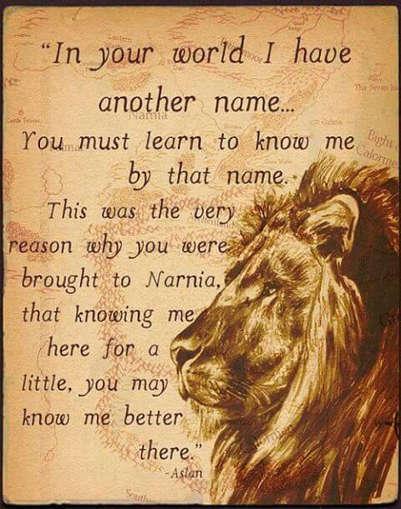When the children are privileged to enter the New Narnia (Heaven) Susan is not with them. Aslan mentioned that Susan had gotten caught up in the world and material things and, by not showing her at all in heaven, Lewis suggests that she is not there. Is it fair to exclude someone from heaven even in fiction?

What does this say about even the best of people (a queen and savior of Narnia) falling to temptation?

“Now the story of Christ is simply a true myth: a myth working on us the same way as the others, but with this tremendous difference that it really happened: and one must be content to accept it in the same way, remembering that it is God’s myth where the others are men’s myths: i.e., the Pagan stories are God expressing Himself through the minds of poets, using such images as He found there, while Christianity is God expressing Himself through what we call 'real things'” -C.S. Lewis. How is Christianity a true myth? Do you like that description of the faith? What is appealing about the “mythos of Christianity?”